SEG Awards Level 2

Motor Vehicle Studies

Underpinning Knowledge Evidence Record

D/601/5425 Knowledge of Removing and Fitting Non Permanently Fixed Motor Vehicle Panels

Learners Name
SEG Awards Registration Number
Centre Name
Assessor 1 Name
Assessor 2 Name

DECLARATION OF AUTHENTICITY

This declaration must be completed and signed by the learner and countersigned by the tutor / assessor and covers all evidence submitted for moderation.

Learner Name
Unique Learner Number (ULN) |  | SEG  Learner Reg. ID
Qualification Title
Centre Name

Learner statement of authenticity

Before signing please read the guidance below.

I confirm, that the attached assignment / portfolio is all my own work and does not include any work completed by anyone other than myself. I have completed the assignment / portfolio in accordance with SEG Awards’ instructions and within the time limits set by my centre.

Signature |  | Date

Centre confirmation of authenticity

On behalf of …………………………………….(insert centre name), I confirm that the above mentioned learner, to the best of my knowledge, is the sole author of the completed assignment / portfolio attached, and the assessments have been completed under the required conditions.

Signed |  | Date
Name
Title

Guidance for Learners

You have been asked to sign this Declaration of Authenticity and place it at the front of your portfolio or course work assessment. It confirms that the work you have submitted for assessment is your own and that you have not copied it from someone else or allowed another learner to copy it from you.

When preparing any course work it is good practice to undertake research using information from published sources. If you quote directly from these sources then this must be indicated in your work by using quotation marks and referencing the document from which the quotation was taken. You must then comment in your own words on any ideas expressed.

Assessors, internal verifiers and SEG Awards’ external moderators and verifiers are subject specialists who can spot the use of published materials that may be passed as your own words or ideas.
If you do copy words from a published source and do not indicate their reference you will be committing plagiarism. This is considered a form of cheating and may result in your assessment being declared void.

Contents

Task No | Title | Assessment Criteria
1 | Procedures for removing and re-fitting non-permanently fixed motor vehicle panels | 1.1, 1.2, 1.3
2 | Fastenings and fixings | 1.4, 1.5
3 | Quality checks | 1.6, 1.7, 1.8, 1.9

Task 1 - Procedures for removing and r-re-fitting non-permanently fixed motor vehicle panels | Assessment Criteria 1.1, 1.2, 1.3

During a pre-work inspection damage has been found on a vehicle in the following locations;
- off-side front wing
- off-side rear passenger door
- tailgate/boot lid
- bonnet
Mark on the diagram below the locations of the damage (using X)
Vehicle Body Report |  | Explain who you would report this damage to and how this would be recorded
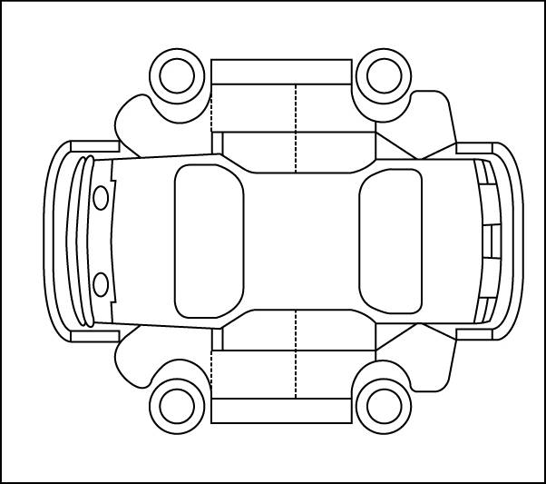

Front Rear
Using a technical resource find the correct procedure for the removal and fitting of each of the items below

Body panels to be removed and  re-fitted | Indicate Sources of Information Used
 | Manual | Autodata | Thatcham eScribe | Internet | Other  (State)
Wing
Door
Bonnet
Boot lid
Tail gate

Explain the procedures involved in the removal and refitting of the following Items
Wing
Door
Bonnet
Boot lid
Tail gate

Identify the procedures and precautions you would use when working with supplementary safety systems (e.g. SRS, Airbag)
Light Vehicle Component/Panel Storage
Components to be removed and  re-fitted | Explain the correct storage method
Wing
Door
Bonnet
Boot lid
Tail gate

Task 2 - Fastenings and fixings | Assessment Criteria 1.4, 1.5

Identify different types of fastenings and fixings used when removing and re-fitting the non-permanently fixed motor vehicle body panels and trim
Panel | Type of fastening/fixing
Wing
Door
Bonnet
Boot lid
Tail gate
From the list of fixings above explain the reasons for the use of the different types of fasteners and fixings

Task 3 - Quality checks | Assessment Criteria 1.6, 1.7, 1.8, 1.9

Alignment and quality checks
Explain the following:
How to correctly align a
non-permanently fixed wing panel
Reasons for correct alignment

List the quality checks that are used to ensure alignment and operation of a
non-permanently fixed body panel
Identify correct conformity of vehicle systems against vehicle specification (e.g. legal requirements)

Unless otherwise stated e.g. for some entry level qualifications, learners can work together but should identify sections which are their own work.

